Legacy Glazer's Diver Pricing Reports Transition

Business Requirements Document

Prepared by: Fernando Villaamil

Table of Contents

2 Revision History 3

2.1 Approvers 4

3 Project Overview 5

3.1 Project Scope 5

4 Business Process 6

4.1 Current (As-Is) 6

4.2 Future (To-Be) 6

4.3 As-Is / To-Be Diagram. 7

5 Functional Requirements 9

5.1 Assumptions, Dependencies, Constraints and Risks 9

5.2 Reporting Requirements 10

5.2.1 Common Reports 10

5.2.2 Data Availability Requests 11

5.3 Data Requirements 11

5.4 Miscellaneous Requirements 12

6 Non-Functional Requirements 13

7 Out of Scope 14

7.1 Functionality 14

8 Appendix 15

8.1 Terms and Abbreviations 15

8.2 User Lists 16

8.2.1 List of Users 16

8.2.2 List of Power Users by Site 16

8.3 Common Report Examples 18

8.3.1 3 Month Pricing 18

8.3.2 SAP Pricing File 18

8.3.3 Pricing Grid 18

8.3.4 12176 Default Pricing (Everyday Discount) 19

8.4 Data Availability Requests Examples 20

8.4.1 ZOR101012176 – Support Agreement GOA and BANK Report 20

8.4.27 12176 Group Pricing (Off-Premise Discount) 20

# Revision History

The Revision History table records significant changes to the business requirements document inclusive of project scope, objectives, cost, risk, design, organization and schedule. The document will be reviewed with both clients and project team regularly through the project life cycle.

| Version | Date  Changed | Revised By | Revision Details/Reason |
| --- | --- | --- | --- |
| 1.0 | 11/08/2018 | F.Villaamil | DRAFT v1 |
|  |  |  |  |
|  |  |  |  |
|  |  |  |  |
|  |  |  |  |

## Approvers

Sign-off indicates that the approver is formally speaking on behalf of his/her business unit and indicating that the requirements presented in the Business Requirements Document have been agreed-to by the business unit and are accurate and comprehensive.

|  |  |  |  |
| --- | --- | --- | --- |
| Name | Email and Title | Approval Date | Version |
| Ann Burns | [ABurns@sgws.com](mailto:ABurns@sgws.com) Director - Accounting Projects, TX |  |  |
| Louis Zweig | [LZweig@sgws.com](mailto:LZweig@sgws.com) SVP Supplier Management - TX |  |  |
| Gary Schwartz | [Gschwartz@sgws.com](mailto:Gschwartz@sgws.com) VP-State, TX |  |  |
| Chris Harris | [ChristopherJ.Harris@sgws.com](mailto:ChristopherJ.Harris@sgws.com)  VP- Regional Finance, MO |  |  |
| Randy Myers | [RMyers@sgws.com](mailto:RMyers@sgws.com) Senior VP – State, MO |  |  |
| Johnny Licciardi | [Johnny.Licciardi@sgws.com](mailto:Johnny.Licciardi@sgws.com) Senior VP, LA |  |  |
| Brian Drobik | [BDrobik@sgws.com](mailto:BDrobik@sgws.com) VP, Commercial Operations, OH |  |  |
| Steve Ryan | [richard.ryan@sgws.com](mailto:richard.ryan@sgws.com) VP - Regional Finance, AR |  |  |
| Matt Xhemajli | [MattXhemajli@sgws.com](mailto:MattXhemajli@sgws.com) Enterprise Technology Innovation Manager, |  |  |
|  |  |  |  |

# Project Overview

## Project Scope

With the implementation of the OneSAP project, Legacy Glazer's data will no longer be sent to the Legacy Glazer's Diver environment. The goal of this project is to bridge the Legacy Glazer’s internal users reporting gap, which is being introduced via the OneSAP migration. Specifically, this project will ensure the successful transition of Pricing Reports from the Legacy Glazer Internal DIVER server to OneSource.

To achieve this the following will take place:

* Transition out of DIVER the Legacy Glazer's Pricing reports as defined in Section 5.2 of this BRD.
* The required reporting source data elements previously accessed via Diver will be transitioned to OneSource. Any data gaps that cannot be addressed will be handled via alternate solutions.
* Internal users will be trained in the selected reports.
* The solutions will be implemented in all Legacy Glazer States – Kansas, Texas, Missouri, Oklahoma, Louisiana, Arkansas, Ohio and Iowa.

# Business Process

## Current (As-Is)

Glazer’s Diver environment contains interactive reports available on a 24/7 basis and updated daily.

The Legacy Glazer Diver Environment is loaded from SAP via the AS/400. The AS/400 is used for transforming the SAP data extracts to DIVER load files and does not play any other functions on the load process

* SAP sends files to the AS/400. There are no ‘scripts’ that send data directly from SAP to Diver
* The AS/400 then runs programs to load these files to the staging tables.
* After that process is complete other programs use the staging tables to create the files that are send to Diver via FTP.

The Diver Reporting environment includes:

* Diver – used for Internal and External Supplier Sales Reports
* ProDiver/Citrix-Diver – for internal users to create and save markers
* Broadcast – allows users to automatically send markers to their email as PDF or Excel files
* Diveport – an online reporting tool for select Suppliers
* Planner (for creation and manipulation of Supplier goals)
* CellDiver (Diver functionality within Excel, used to create trackers)

## Future (To-Be)

As part of this project all Pricing reports listed in Section 5.2 of this BRD will be transitioned out of DIVER. The required source data elements for these reports previously accessed via Diver will be transitioned to OneSource.

If there are any data gaps (identified in section 5.3 Data Requirements) that cannot be addressed, they will be handled via an alternate solution.

## As-Is / To-Be Diagram.

**AS-IS**

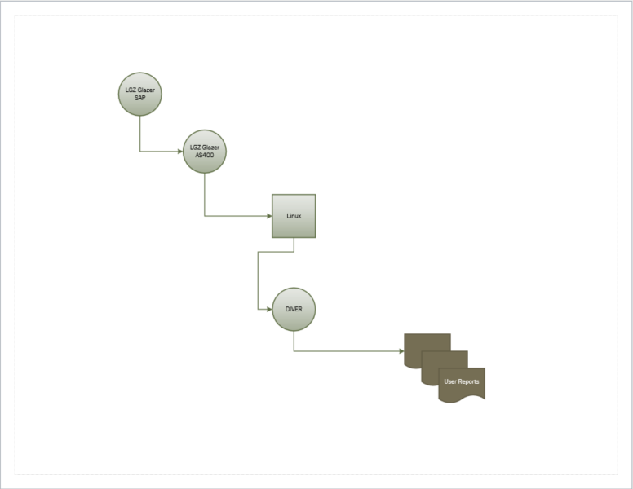

**TO-BE**

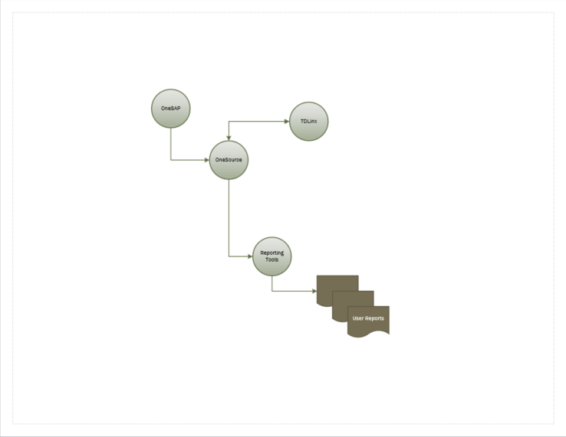

# Functional Requirements

## Assumptions, Dependencies, Constraints and Risks

A – Assumption: accepted as true or as certain to happen

D - Dependency

C – Constraint: a limitation or restriction

R – Risk: threat of any negative occurrence

|  |  |  |  |
| --- | --- | --- | --- |
| ID | ADCR | RISK AREA | Description |
| ADCR_030 | A | Reporting | For each DIVER site the following will be identified:   * List of users impacted by the change * Reporting SME/s for each site * The SME’s that will be involved in UAT testing * Scope of training required – reporting tool, online, webinar, onsite, etc. |
| ADCR_031 | R | Reporting | There is no Technical Developer at SGWS for DIVER. |
| ADCR_032 | R | Reporting | The logic/code used to generate the DIVER reports is not known. |
| ADCR_033 | A | Data Needs | All data currently used by DIVER will be in OneSource |
| ADCR_034 | A | Data Needs | Historical Data for the last 7 years will be available for reporting. |
| ADCR_035 | A | Data Needs | Any data not brought in to OneSource by the OneSAP project but required for this project must be addressed. This scope will require ABAP programmers. |
| ADCR_036 | A | Miscellaneous | Business Objects (Webi) will be the preferred reporting tool |
| ADCR_037 | R | Miscellaneous | ETP QA lacks experience with Diver. |
|  |  |  |  |

## Reporting Requirements

### Pricing Reports

Pricing Reports are dependent on pricing data being brought into OneSOurce from SAP.

|  |  |  |  |
| --- | --- | --- | --- |
| ID | Priority | Description | Approver |
| REQ_084 |  | 3 Month Pricing Report  See Common Report Examples 3 Month Pricing  List price and current price by item for current month and next month with sales for last three months, inventory on hand and inventory on order. | Chris Harris  Carol Burns |
| REQ_085 |  | Pricing Structure Report  See Common Reports Examples SAP Pricing File  Item cost and pricing details for all pricing levels.  With inventory totals by warehouse location. General Product Info by Vendor. Pricing discount levels, profit, margins, cases, dollars by WH, trends and TY/LY aggregations. | Ann Burns |
| REQ_086 |  | Pricing Grid Report  See Common Reports Examples Pricing Grid  This report is by Vendor and lists items, QD start and end dates, group deals discounts, level, status. Warehouse and material number, case qty, discounts, future charges, bottle and pack UPC and inner UPS | Ashley Litton |
| REQ_087 |  | 12176 Default Pricing (Everyday Discount)  See Common Reports Examples 12716 Default Pricing (Everyday discount). | Evelyn Dubois |

### Data Availability Requests

|  |  |
| --- | --- |
| ID | Description |
| REQ_100 | 12176 Group Pricing. Evelyn Dubois TX  See Common Reports Examples 12176 Group Pricing  Group Type SKU Deals discount report |
| REQ_101 | ZOR101012176 Support Agreement GOA and BANK Report Evelyn Dubois TX  See Common Reports Examples ZOR101012176  This report displays item by distribution channel and vendor. GOA is the money that vendor put in a bank to support marketing effort. |
|  |  |

## Data Requirements

| ID | Description | Report Reference |
| --- | --- | --- |
|  |  |  |
|  |  |  |

## Miscellaneous Requirements

| ID | Description |
| --- | --- |
| REQ_140 | Reporting tool licenses as well as access to the Development, UAT and Production environments will be procured as needed for all users, developers and project team members. |
| REQ_141 | The power users listed in Section 8.3 will be trained on the tools and data sources. Training is a part of this project and we will follow the existing process in place by the PMO to request training resources. |
|  |  |

# Non-Functional Requirements

This section lists the Non-Functional Requirements for the project.

| ID | Description |
| --- | --- |
| NFR_001 | The reporting solution shall accommodate 1580 users concurrently |
|  |  |

# Out of Scope

## Functionality

|  |  |
| --- | --- |
| ID | Description |
| OOS_010 | “Standardization of reports is out of scope”.  The reports will be built as-is (i.e., as per attached examples) |
| OOS_011 | HANA Reporting. |
| OOS_012 | Business Objects (BO) Analysis - Excel Plug-In. AO |
| OOS_013 | “Real Time” reporting. |
| OOS_014 | Development of Ad-Hoc reports. |
| OOS_015 | Goals Reporting (DI_Planner/Dimensional Insights). The plan for the Central Region is to track the goals totally in Excel until an Enterprise Wide solution is enabled. |
| OOS_016 | Development/Transitioning of reports outside the list of the Legacy Glazer's common reports listed ins Section 5.2 within the requirements. |
| OOS_017 | External DIVER reporting to suppliers (e.g., DIVEPORT). The VIP Project will address the supplier reporting. |
|  |  |

# Appendix

## Terms and Abbreviations

|  |  |
| --- | --- |
| Term/Abbreviation | Definition |
| ABC | Alcohol Beverage Commission |
| BO | Business Objects |
| Business Objects | SAP Business Objects BI - SAP Business Objects BI (SAP BO, also historically BOBJ) is a reporting and analytics business intelligence (BI) platform aimed at business users. It consists of many reporting applications that allow users to discover data, perform analysis to derive insights and create reports that visualize the insights. |
| DIVER or DIVER BI | Diver BI from Dimensional Insight is a business intelligence and information delivery platform |
| ETA | Estimated Time of Arrival |
| PDF | A file format that provides an electronic image of text or text and graphics that looks like a printed document and can be viewed, printed, and electronically transmitted. |
| R12 | Rolling 12 Months |
| BI HANA | Business intelligence (BI) on SAP HANA, leveraging it both as a data source and as a platform. SAP Business Objects BI 4.1 is optimized for SAP HANA with new features that take advantage of the speed and agility offered by SAP HANA. |
| HANA | SAP HANA is an in-memory, column-oriented, relational database management system developed  and marketed by SAP SE. Its primary function as a database server is to store and retrieve data as requested by the applications. In addition, it performs advanced analytics (predictive analytics,  spatial data processing, text analytics, text search, streaming analytics, graph data processing) and includes ETL capabilities as well as an application server. |
| Webi | SAP Webi - Web Intelligence is part of SAP Business Objects product suite and is used for analytical and ad hoc reporting to meet an organization’s business requirements. Web Intelligence is a Business Intelligence reporting tool for business users to analyze data in Data Warehouse. It assists business managers in the decision-making process for building future strategies.  Using Web Intelligence, business users can create basic, medium, and complex reports from transactional data in database and by creating Universes using Information Design Tool/UDT. Various SAP and non-SAP data sources can be used to create reports in Web Intelligence. SAP Business Warehouse (BW) system doesn’t require a Universe to connect to Web Intelligence tool.  Web Intelligence tool can work as a client tool of Business Objects platform and as a standalone tool for reporting. |

## User Lists

### List of Users



### List of Power Users by Site

#### Kansas

* Carol Burns [CBurns@sgws.com](mailto:CBurns@sgws.com)
* Victoria Cooksey [victoria.cooksey@sgws.com](mailto:victoria.cooksey@sgws.com)
* Chris J Harris [christopherj.harris@sgws.com](mailto:christopherj.harris@sgws.com)
* Robin Rank [Robin.Rank@sgws.com](mailto:Robin.Rank@sgws.com)
* Elizabeth Mitchell [EMitchell@sgws.com](mailto:EMitchell@sgws.com)
* Yvonne Paiz [Yvonne.Paiz@sgws.com](mailto:Yvonne.Paiz@sgws.com)

#### Louisiana

* Michael Slater [Michael.Slater@sgws.com](mailto:Michael.Slater@sgws.com)
* Juliana Purcello [Juliana.Purcello@sgws.com](mailto:Juliana.Purcello@sgws.com)
* Colin Davis-McElligatt [colin.mcelligatt@sgws.com](mailto:colin.mcelligatt@sgws.com)
* Lisa Ackoury [LAckoury@sgws.com](mailto:LAckoury@sgws.com)
* Blaine Bennett [Blaine.Bennett@sgws.com](mailto:Blaine.Bennett@sgws.com)
* Debra Hays [DHays@sgws.com](mailto:DHays@sgws.com)
* Brian Edgeworth [brian.edgeworth@sgws.com](mailto:brian.edgeworth@sgws.com)

#### Arkansas

* Emily Hubbard [Emily.Hubbard@sgws.com](mailto:Emily.Hubbard@sgws.com)
* Kim Lemmons [Kimberly.Lemmons@sgws.com](mailto:Kimberly.Lemmons@sgws.com)
* Sarah Craig [sarah.craig@sgws.com](mailto:sarah.craig@sgws.com)
* Tanya Baxter [TBaxter@sgws.com](mailto:TBaxter@sgws.com)

#### Missouri

* Lisa Ligon [LLigon@sgws.com](mailto:LLigon@sgws.com)
* Gail Bendel [GBendel@sgws.com](mailto:GBendel@sgws.com)
* Tyler Row [Tyler.Row@sgws.com](mailto:Tyler.Row@sgws.com)
* Nicole Ciocarelli [nicole.ciocarelli@sgws.com](mailto:nicole.ciocarelli@sgws.com)
* Brian Collins [Brian.Collins@sgws.com](mailto:Brian.Collins@sgws.com)
* Diana Hinchey [DHinchey@sgws.com](mailto:DHinchey@sgws.com)
* Chris J. Harris [christopherj.harris@sgws.com](mailto:christopherj.harris@sgws.com)

#### Texas

* Brock Addicks [BAddicks@sgws.com](mailto:BAddicks@sgws.com)
* Jessica Ricks - Tassell [Jessica.Tassell@sgws.com](mailto:Jessica.Tassell@sgws.com)
* Paul Hansen [Paul.Hansen@sgws.com](mailto:Paul.Hansen@sgws.com)
* Jim Henk [JHenk@sgws.com](mailto:JHenk@sgws.com)
* Matthew (Matt) Hodson [MatthewHodson@sgws.com](mailto:MatthewHodson@sgws.com)
* Janet Shawver [JShawver@sgws.com](mailto:JShawver@sgws.com)
* Gabby Villafana [Gabriela.Villafana@sgws.com](mailto:Gabriela.Villafana@sgws.com)
* Colin McElroy [Richard.McElroy@sgws.com](mailto:Richard.McElroy@sgws.com)
* Tracy Kosub [TKosub@sgws.com](mailto:TKosub@sgws.com)
* Kathleena (KC) Reneau [kathleena.reneau@sgws.com](mailto:kathleena.reneau@sgws.com)
* Markus Balderach [markus.balderach@sgws.com](mailto:markus.balderach@sgws.com)
* Jason Cottle [JCottle@sgws.com](mailto:JCottle@sgws.com)
* Josiah Samuel Unger [samuel.unger@sgws.com](mailto:samuel.unger@sgws.com)

#### Iowa

* Amy Burgess – Iowa [ABurgess@sgws.com](mailto:ABurgess@sgws.com)
* Nicholas Wood – Ohio [Nicholas.Wood@sgws.com](mailto:Nicholas.Wood@sgws.com)

#### Ohio

* Bill Jansen [William.Jansen@sgws.com](mailto:William.Jansen@sgws.com)
* Brian Drobik [BDrobik@sgws.com](mailto:BDrobik@sgws.com)
* Deb Kennison [Debbie.Kennison@sgws.com](mailto:Debbie.Kennison@sgws.com)
* Jeremy Lindsey [Jeremy.Lindsey@sgws.com](mailto:Jeremy.Lindsey@sgws.com)
* Beth Bold [BBold@sgws.com](mailto:BBold@sgws.com)
* Rebecca Thomas [Rebecca.Thomas@sgws.com](mailto:Rebecca.Thomas@sgws.com)

#### Oklahoma

* Diane Vandivort [Diane.Vandivort@sgws.com](mailto:Diane.Vandivort@sgws.com)
* Theresa Mahan [Theresa.Mahan@sgws.com](mailto:Theresa.Mahan@sgws.com)
* Llaurie Ormiston [Laurie.Ormiston@sgws.com](mailto:Laurie.Ormiston@sgws.com)

## Common Report Examples

### 3 Month Pricing



### SAP Pricing File

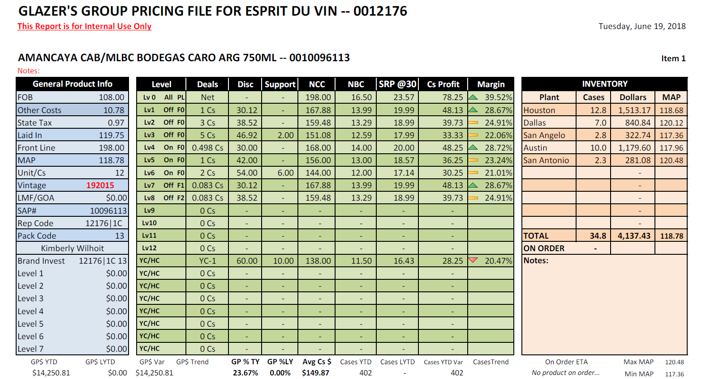

### Pricing Grid

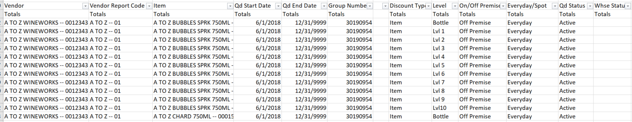

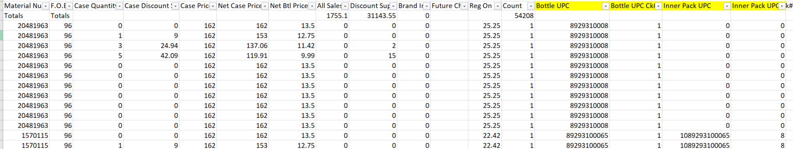

### 12176 Default Pricing (Everyday Discount)

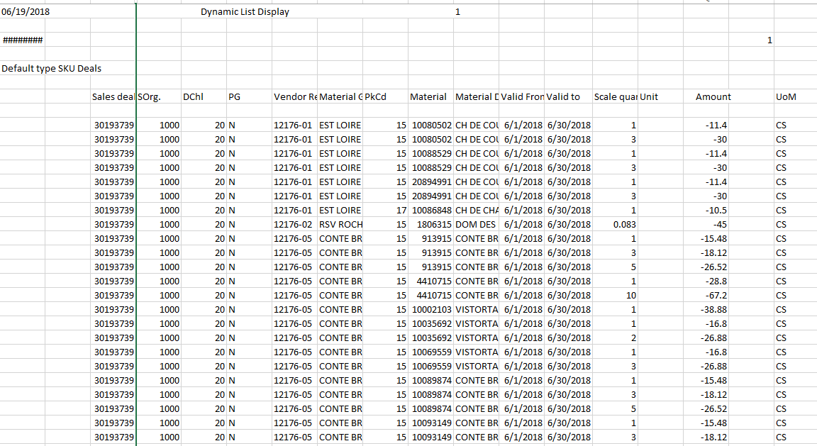

## Data Availability Requests Examples

### ZOR101012176 – Support Agreement GOA and BANK Report

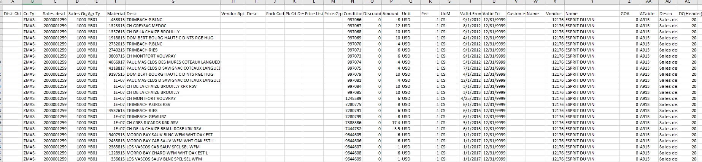

### 12176 Group Pricing (Off-Premise Discount)

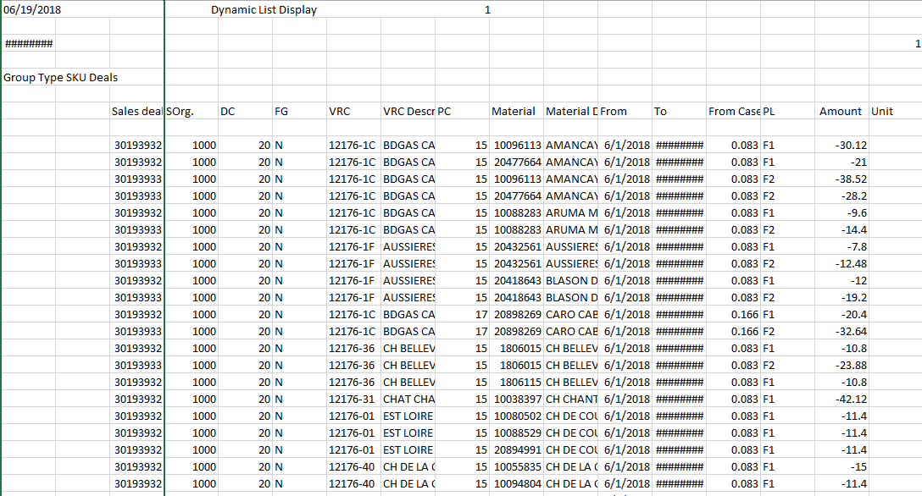

## Pricing Data Compare

